Launch into challenger PTA  September Newsletter  box tops  All you need is your phone! Download the Box Tops App, shop as you normally would, then use the app to scan your store receipt within 14 days of purchase. The app will identify Box Tops products on your receipt and automatically credit Challenger’s earnings online!  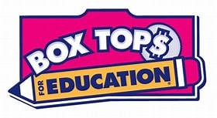  Amazon smile  Just go to smile.amazon.com and choose Challenger Elementary School as your charity, then every time you shop, you will be supporting our school. You will find the exact same low prices, vast selection, and convenient shopping!  Volunteers Needed  There are many opportunities to show your support! Please visit our website to learn about membership and volunteer opportunities! Be sure to follow us on social media for PTA events and school information.  https://challengerpta.ourschoolpages.com/Home | Coming Soon:  SpiRit wear  SEPTEMBER 20TH-  OCTOBER 17TH  Trick or Treat  October 28th  6:30-8:00 pm  dance-a-thon  November 18th  virtual story night  LIVE WITH PROMISE  Lead our children to a promising future  Involve every parent  Voice for every child  Enrich the community  2021-2022  Challenger Elementary School

